- a)
Family name and traits (traits used to place this fish in family):

b)
Family name and traits (traits used to place this fish in family):

c)
Name two interesting characteristics about this fish:

- a)

b)

c)
Family name and traits (traits used to place this fish in family):

- a)

b)Fish:
Invertebrate:

c)
Family name and traits

- a)
What sex is this fish? What are some unique traits of this family?

b) What family amongst the flatfish does this fish belong?

c)
What group of crabs does this belong to:

- a)

b)

c)

- What is this, a plant or an algae.
  - Name the three varieties

- a)

b)

c)

d)

- There are three organisms in this container, name all three:

- There are two organisms (do not include plant), name both:

- a)

b)

c)

- a)

b)

- a)

For b, c, d is this a sponge or tunicate

b)

c)

d)
Additionally, what is the name of this organism?

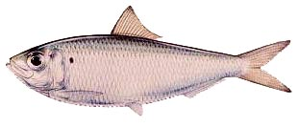
13. What is this fish? What family does it belong to? Name three family traits?

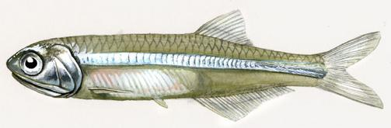
14. What is this fish?

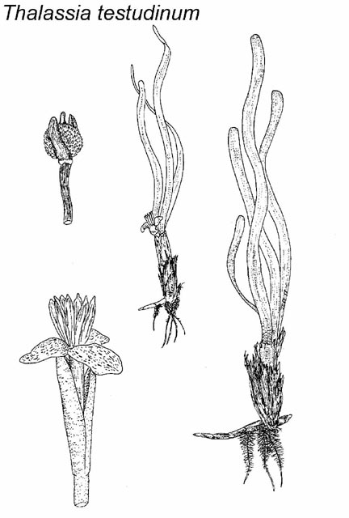

15. Place a name next to these three seagrasses:

